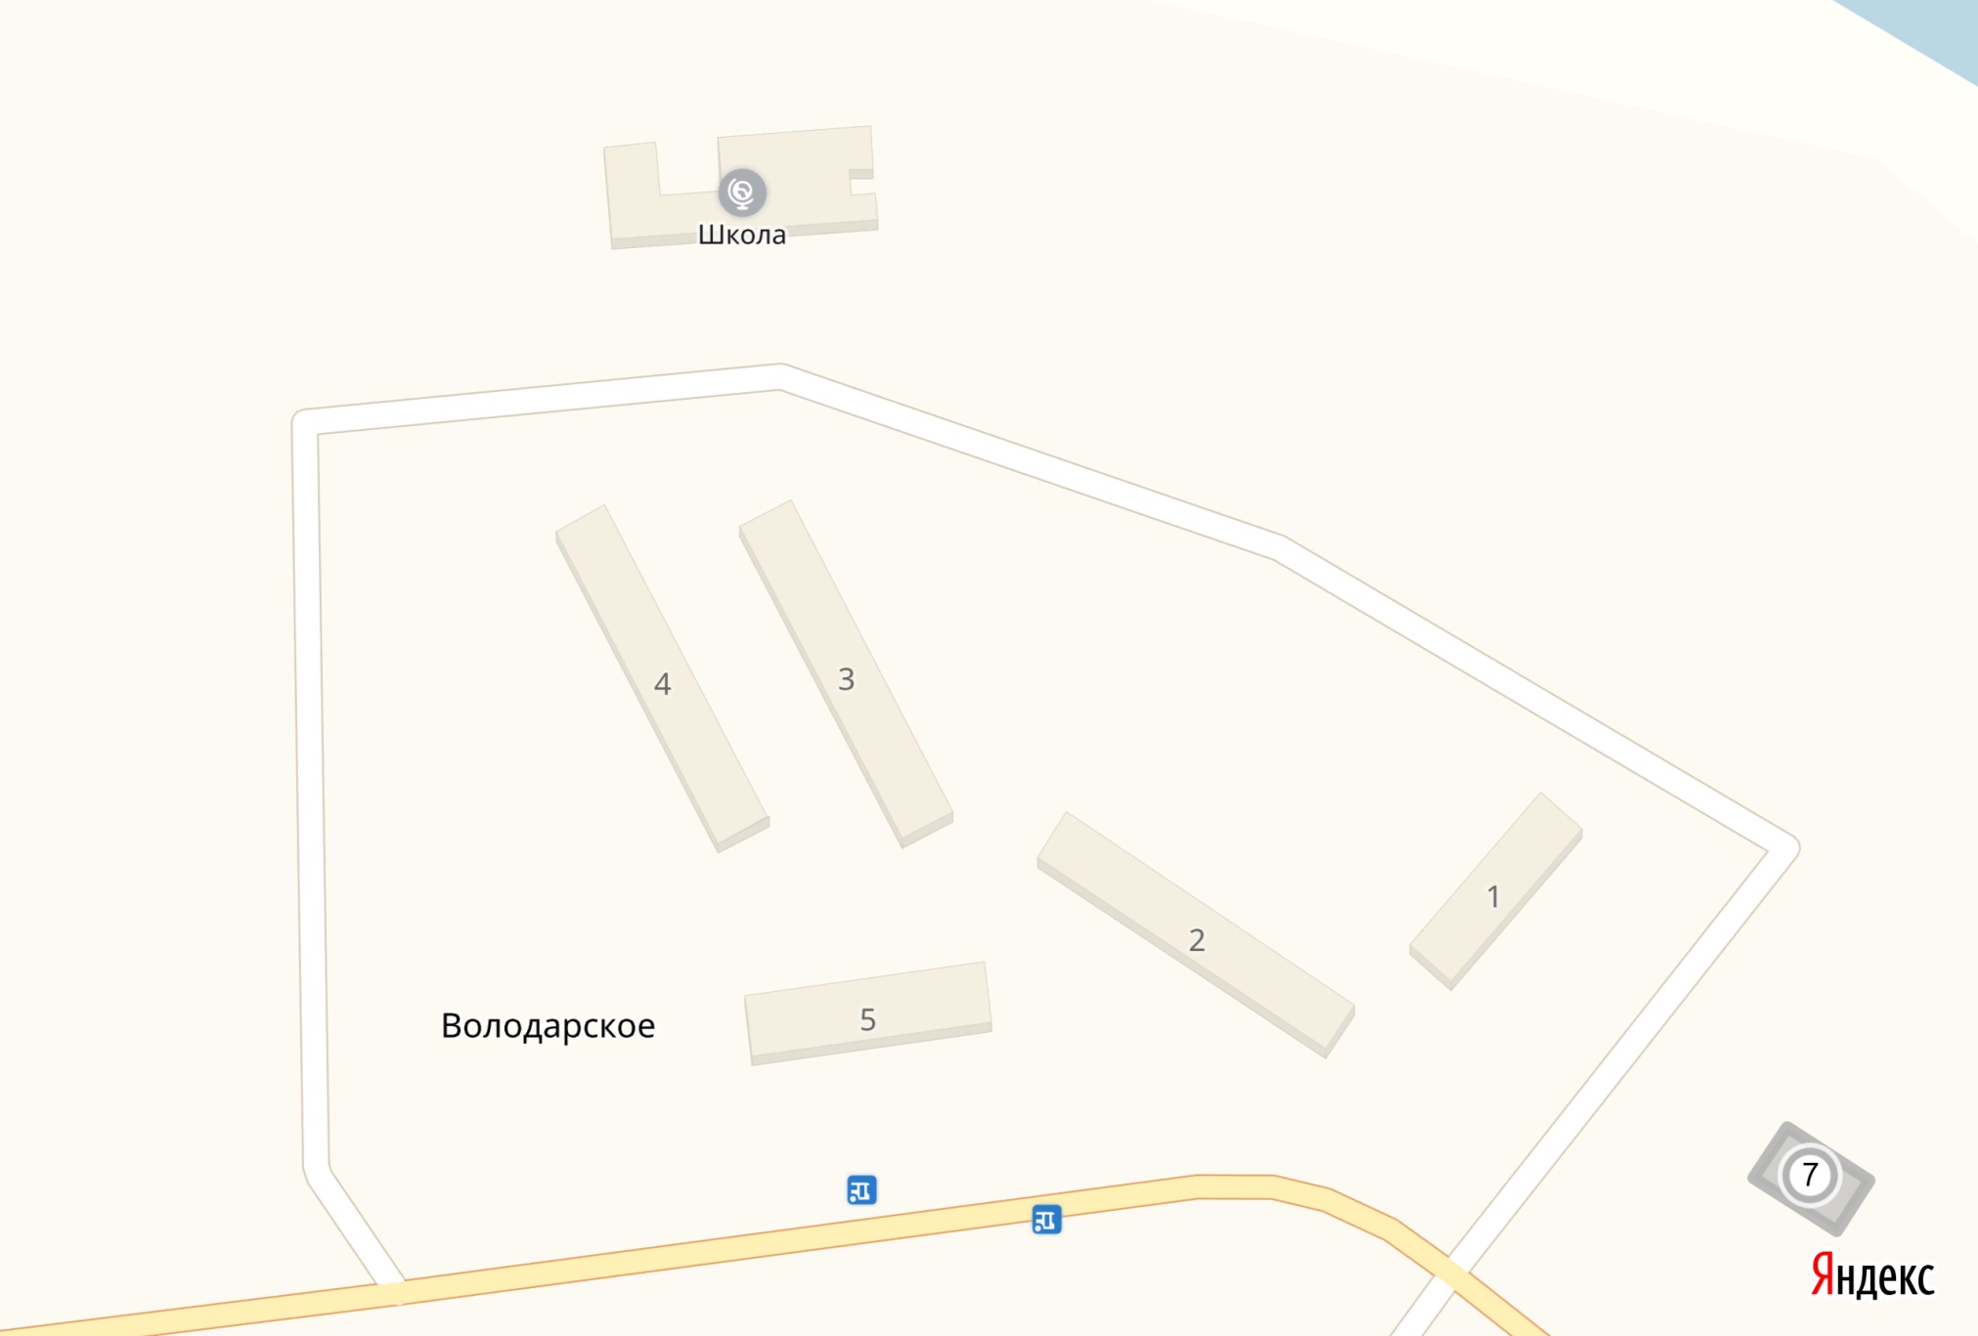

*3.2*

*3.3*

*3.4*

*3.1*